Muralidharan D
[Email address]
AuRA AI Discovery Framework
Functional Document

Contents
Objective 2
Application Flow Overview 2
Functionality 2
Screen 1: Client Onboarding 2
Screen 2: High-Level Process Context 3
Screen 3: Process Volumetrics & Pain Points 4
Screen 4: Activity Breakdown 5
Screen 5: GSDA Evaluation (System Generated) 6
Screen 6: AI Archetypes / Solution Types 7
Screen 7: Evaluation Summary (System Output) 7
Appendix 8
Screenshots 8

Objective
The objective of the AURA Discovery application is to conduct AI-enabled process discovery by analyzing user-provided process details, documentation, and diagrams. The application utilizes AI to break down processes into individual activities and provide tailored solution recommendations. This empowers organizations to assess the feasibility, readiness, and potential benefits of adopting AI automation within their targeted business processes

Application Flow Overview
The application consists of 7 progressive steps. The first 3 steps involve direct user input. Steps 4 to 7 are system-generated using AI logic and internal mappings based on the inputs, and those are editable.
Step Breakdown:
- Client Onboarding (User Input)
- High-Level Process Context (User Input)
- Process Volumetrics & Pain Points (User Input)
- Activity Breakdown (System+ Manual Override)
- GSDA Evaluation (System Generated + Manual Override)
- AI Archetype / Solution Types (System Suggested + Manual Override)
- Evaluation Summary (System Generated + Manual Override)

Functionality
Dashboard:
Description:
This screen captures the high-level overview about the created assessments and access navigation to different areas such as Client Management, New Assessment and also Existing Assessments.
Top Navigation Section:
Element | Functionality
Add New Assessment | Launches the multi-step assessment form starting from Step 1 (Client Onboarding).
Manage Clients | Opens the Client Profile Management screen to add/edit clients
View Report | Navigates to the Report Center to view/download completed assessment summaries.

Assessment KPIs:
Card | Purpose
Total Assessments | Displays number of total assessments in the platform.
Completed | Count of completed assessments, ready for download/report view.
In Progress | Ongoing assessments that are partially filled.
Estimated Value | Summary of AI opportunity value (auto-calculated from business metrics in Step 6/7).

Search & Filter:
Component | Functionality
Search Bar | Keyword-based filtering across clients, process areas, statuses
Filter Chips | Toggle between All, In Progress, Completed states for visible assessment cards

Assessment Cards Section:
Card Component | Function
Client Name | Identifies the organization
Process Area | Which process is being assessed (e.g., Finance, Supply Chain)
Status Badge | Visual status of assessment: In Progress, Completed, Draft, etc.
Label: Progress Bar | May lead to a visual progress bar or % completion of multi-step form
Card Click / Tap | Opens the assessment form to resume or view (based on status)

Client Profile Management screen
Description:
Displays all registered clients in a table format with the following columns:
In the view list screen, List of fields to show are listed below.
Field | Description
Client Name | The company or organization's name
Industry | Domain/sector (e.g., Manufacturing, Retail, BFSI)
Client Representative | Name + title of the key contact (e.g., Sandeep – CTO)
Created On | Date when the client was first onboarded
# Assessments | Number of assessments completed or in progress for the client
Actions | Buttons: View, Edit, Add New Assessment

Fields to be captured on creation of new customer,
Field | Input Type
Client Name | Text
Industry / Sector | Dropdown
Client Representative Name | Text
Email | Email
Phone Number | Numeric
Role / Title | Text
Default Business Function | Dropdown (Finance, HR, etc.)
Date Created | Date Picker

Search & Filter Tools
- Search box to filter clients by Name

Screen 1: Client Onboarding
Description:
This screen captures client-level information required to initiate an assessment.
Fields:
Field Name | Type | Example | Validation / Notes
Client Name | Auto Suggest | Ventora Pvt Ltd | Suggest based on Client Management
Industry / Sector | Dropdown | Manufacturing | Fetched from Client Management on choosing Client name and its Editable
Client Representative Name | Auto fetched  Text | Sandeep R
Email |  | sandeep@ventora.com
Phone Number |  | 9876543210
Role / Title |  | CTO
Assessment Created Date | Date Picker | 15/07/2025 | Current date is Auto fetched and allows to Edit
Business Function | Dropdown | Finance | Required field
Process Area | Text | Accounts Payable | Required field
Assessment Owner | Text | Murali | Internal user

Screen 2: High-Level Process Context
Description:
The purpose of this step is to gain a clear understanding of the business process, identify the challenges encountered, and clarify the client's goals and desired outcomes.
Fields:
Field Name | Type | Example | Notes
Process Name | Text Area | AP Processing | Required
Process Description | Text Area | Manual AP processing with invoice classification | Required
Goals and Objective | Bullet List | Automate invoice approvals, reduce cycle time | 3-5 goals expected
Existing Systems/Tools | Multi-Input | SAP, Excel | Optional
Maturity Level | Dropdown | Optimized | Dropdown: Ad-hoc, Defined, Automated, Optimized
Process Flow Docs Upload | File Upload | SOP.pdf, Flowchart.png | Optional
SOP Docs Upload | File Upload | SOP.pdf, Flowchart.png | Optional
Volumetrics Docs Upload | File Upload | SOP.pdf, Flowchart.png | Optional
KPI Docs Upload | File Upload | SOP.pdf, Flowchart.png | Optional
Process Summary | Text | AI Generated based on the imported file | Optional
SOP Summary | Text | AI Generated based on the imported file | Optional
Volumetrics Summary | Text | AI Generated based on the imported file | Optional
KPIs Summary | Text | AI Generated based on the imported file | Optional

Screen 3: Process Volumetrics & Pain Points
Description:
This page helps collect volumetric details, cost/risk metrics, and other operational inputs to quantify transactional details and determine future benefit of the automation
Fields:
Field | Type | Example | Notes
Key Challenges | Bullet List | High volume, poor PO matching | Required
Success Metrics | Table | KPI: Cycle time, Accuracy %, Errors/month, SLA Compliance %, Approval TAT. | Optional
Monthly Transaction Volume - Cost | Text Area | How many times does the process run per month. | Optional
FTE Count - Cost | Text Area | Number of full-time employees managing or involved in the process. | Optional
Average Time per Transaction (mins) - Cost | Text Area | The average time taken to complete one cycle of the process. | Optional
Average Revenue per Transaction - Revenue | Number | Monetary value generated or enabled per transaction. | Required
Revenue Leakage - Revenue | Decimal | Estimated annual revenue lost due to inefficiencies or errors. | Optional
Delay Impact on Revenue (%) - Revenue | Number | Percentage of revenue delayed due to process bottlenecks. | Optional
Risk-prone Transactions Count - Risk | Number | Monthly number of high-risk or error-prone transactions. | Optional
Avg. Financial Risk (per txn) | Currency | Estimated financial loss if a risky transaction fails or goes wrong. | Optional
SLA Breach Rate (%) - Risk | Text Area | Percentage of cases not completed within agreed timelines. | Required
Key improvement Areas | Text Area | Auto classification, GL code validation | Optional

Screen 4: Activity Breakdown
Description:
Based on the process details given in the previous pages, AI model breaks down the process into activities. It also determined the data requirement; it’s availability and integration feasibility. The user can modify the activities and other details and add or delete activities
Table Fields:
Field Name | Type | Example | Notes
Activity Name | Text | Invoice Validation | Logical step or subprocess name
Data Needed | Text Area | PO Number, Invoice line items, GRN, Supplier info | Key input data needed to perform activity
Data Readiness | Dropdown | Available via email/supplier portal | Available, Partial, Missing
AI Automation Potential | Dropdown | High | Subjective effort estimate (Low, Medium, High)
Integration Readiness | Text | SAP BAPI, Email parsing | Methods or APIs available for integration
Frequency | Dropdown | Daily / Weekly / Monthly | Occurrence rate

This section will be used to generate GSDA in the next step.

Screen 5: GSDA Evaluation (System Generated)
Description:
Based on the activity breakdown, the AI generates Goals, Signals, Decisions and Actions based on process activities, data readiness, and volumetrics.
Structure:
Field | Example
Goal | Automate invoice extraction and classification
Signal | Invoice received via email
Decision | Is PO present? Are all fields valid?
Action | Extract via OCR → Validate → Send for approval → Park in SAP

Each step will also show:
- Time estimate
- System involved (e.g., Outlook, SAP)
- Data Type (Structured/Unstructured)
- Complexity (Low/Med/High)
- Frequency (Daily, Weekly)
- AI Scope Suggestion (OCR, LLM, Rule-based Decision)
🔷 Goal Section:
Field Name | Type | Example | Notes
Key Goals | Bullet List | Automate invoice processing, improve accuracy | System-generated based on earlier inputs
Priority Level | Dropdown | High / Medium / Low | Assigned by system or user review
Related Activity | Auto-filled | Invoice Validation | Pulled from Activity Breakdown

🔷 Decision Section:
Field Name | Type | Example | Notes
Decision Logic | Text Area | Is PO present? Are mandatory fields valid? | Evaluative criteria
Decision Owner | Text | AP Team or Approver Group | Optional, if manual approval exists
Decision Criteria Source | Dropdown | Policy Document / SOP / Stakeholder Input | Where the rule originates

🔷 Signal Section:
Field Name | Type | Example | Notes
Input Trigger | Text | Invoice received via email or supplier portal | What initiates the process
Data Type | Dropdown | Structured / Unstructured | Type of incoming data
System of Origin | Dropdown | Outlook / SAP / In-house | Where the signal comes from

Screen 6: AI Archetypes / Solution Types
Description:
System recommends AI capabilities to automate or enhance each activity.

Structure:
Process Activity | Suggested AI Archetypes | Justification | Implementation Readiness
Invoice Receipt | OCR, Document Understanding | Unstructured PDF via email | High
Invoice Validation | LLM, Auto Classification | Field matching, tax ID validation | Medium
PO/Non-PO Matching | RPA, Rule Engine, Recommender | Line item and quantity validation | Low

Manual override is available.
List the Implementation priority and the next steps listed as below:
Implementation Priority:
Implementation Phase | AI Archetype | Implementation Priority
Phase 1 | Document Intelligence | High
Phase 2 | Intelligent Routing | medium

Next Steps:
- Review and finalize AI archetype mappings
- Review and finalize AI archetype mappings
- Review and finalize AI archetype mappings

Screen 7: Evaluation Summary (System Output)
Description:
This screen displays the complete AI opportunity report generated by the system.
Sections:
- Key Challenges (based on user input)
- Strategic Goals
- Recommended AI Archetypes
- Expected Business Benefits (Cycle time, Accuracy, FTE Reduction)
- Volumetrics Summary (Invoice count, PO %, Vendors, Risk)
- Suggested Outputs (Auto-tagging, Exception Routing)
- Tech Stack (OCR engine, LLM, SAP connector)
This page is used to generate a downloadable assessment report (PDF/Slides).

Example:

🔺 Key Challenges
- Manual handling of ~6000 invoices/month with inconsistent formats (PDF/image/email).
- 60% of invoices are Non-PO and require additional manual validation.
- Delayed approvals due to unclear routing and lack of standard workflow.
- Dependence on email makes tracking and compliance difficult.
- Lack of real-time visibility and high risk of human error in invoice posting.

🎯 Strategic Goals
- Automate invoice data capture from all input sources (PDF, XML, email).
- Classify and validate invoices intelligently (PO vs Non-PO).
- Enable approval routing with minimal manual touch.
- Integrate seamlessly with SAP for touchless invoice posting.
- Reduce cycle time and increase processing accuracy.

🤖 Recommended AI Archetypes
Process Activity | Recommended AI Solutions
Invoice Receipt & Capture | OCR, Document Understanding
Invoice Validation | LLM-Based Field Validator, Auto Classification
PO / Non-PO Matching | Rule-Based Engine, RPA Bot, Predictive Matching, Recommender

💡 Expected Business Benefits
Metric | Current | Post-Automation (Projected) | Improvement
Invoice Cycle Time | 5.5 mins/invoice | 2.0 mins/invoice | ~63% Faster
First-Pass Accuracy | 70% | 95% | +25% Improvement
Manual FTE Load | 3.5 FTEs | 1.0 FTE (monitoring) | 70% Reduction
SLA Compliance | 60% | 95% | 35% Increase

📊 Volumetrics Summary
- Monthly Invoice Volume: 6,000
- PO vs Non-PO Split: 40% PO / 60% Non-PO
- Vendors: 160 total (80% recurring)
- Risk-prone Transactions: ~2,500/month
- Average Risk Impact (estimated): ₹200–₹300 per error

✅ Suggested Outputs
- Auto-extracted invoice metadata pushed to approval queue
- Smart classification of PO / Non-PO
- Auto-tagging of cost centers and approvers
- SAP entry created automatically post-approval
- Exception routing for low-confidence or missing data cases

🛠 Recommended Tech Stack
Component | Tool / Technology
OCR Engine | AWS Textract / Tesseract
Language Model | OpenAI GPT / Azure OpenAI (LLM Validator)
Business Rule Engine | Custom Rules Framework (for classification)
Workflow Bot | UiPath / Power Automate
SAP Integration | SAP BAPI / Docs / RPA Connector
Dashboard / Reporting | Power BI / Grafana

Appendix:
Screenshots:
Client Management Screen
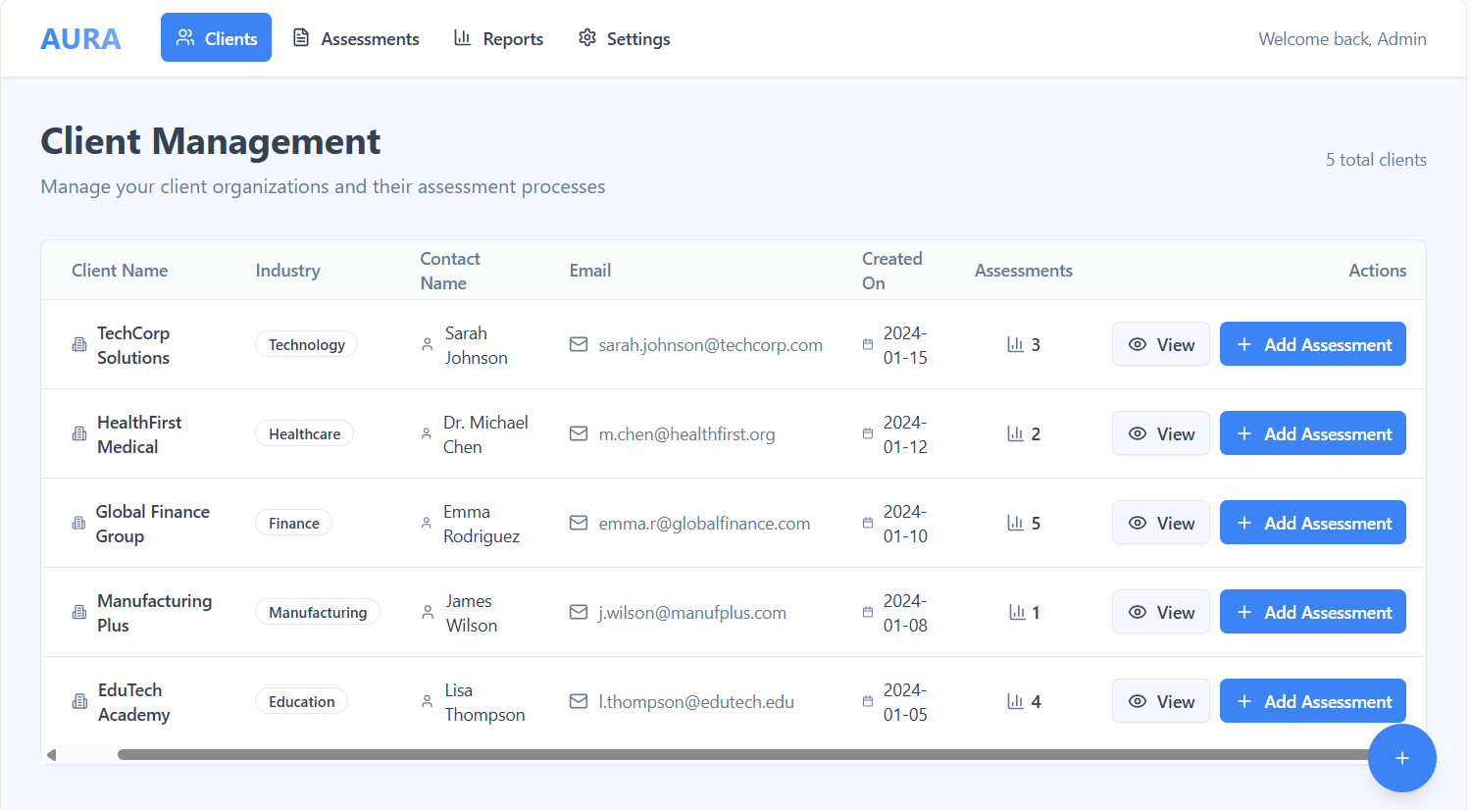
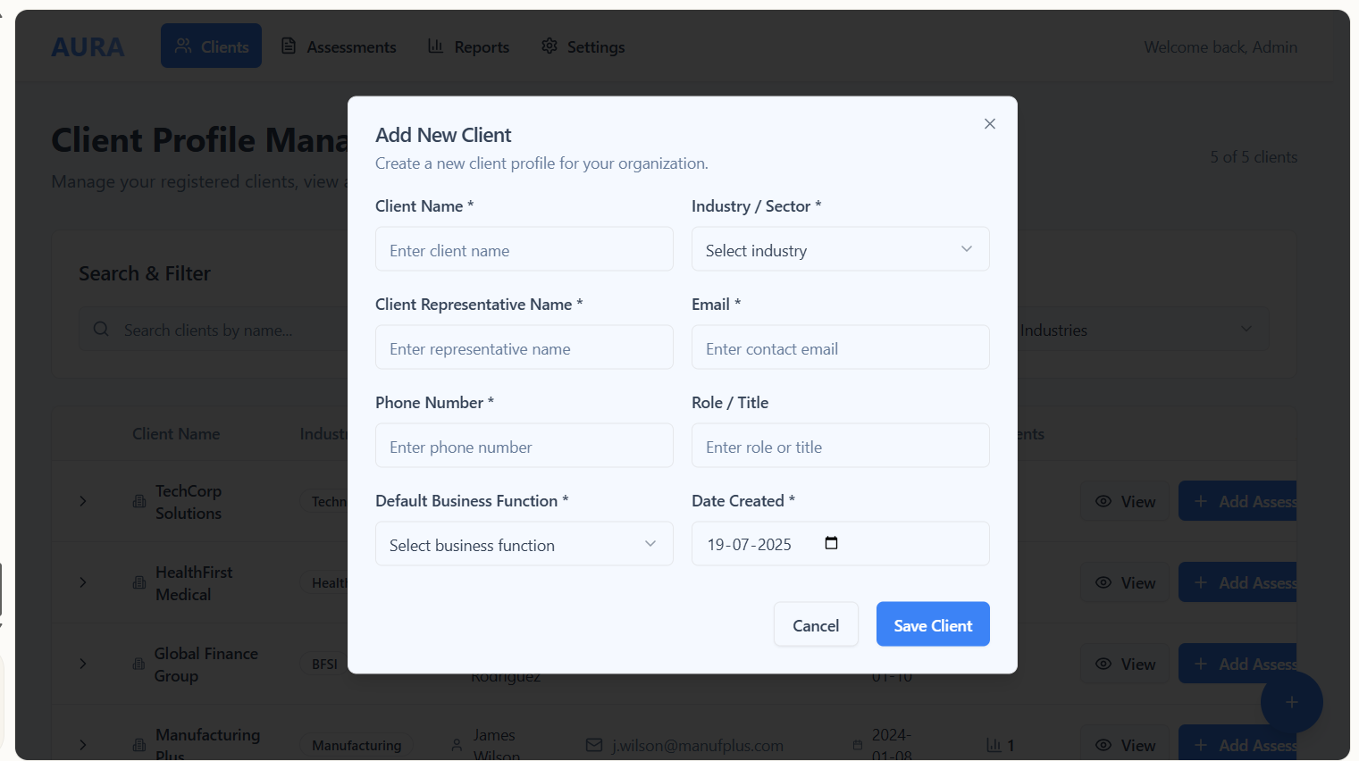
Dashboard:
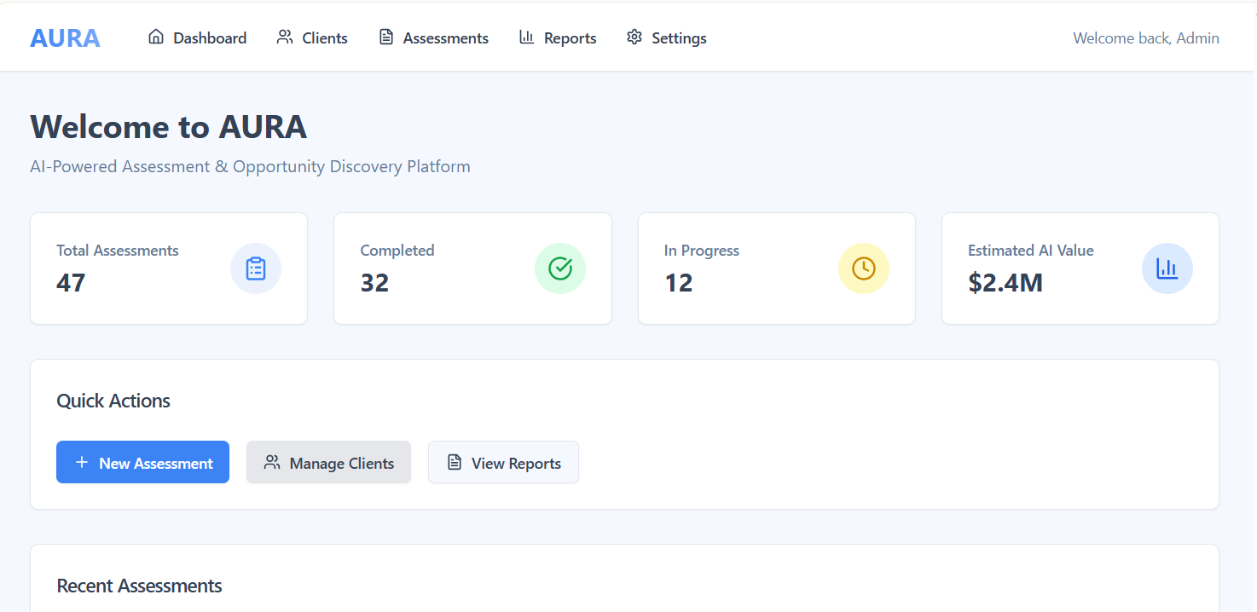
Client Onboarding Client Onboarding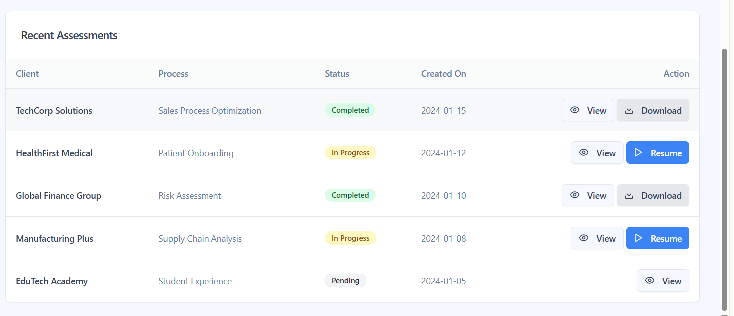

Client Onboarding:
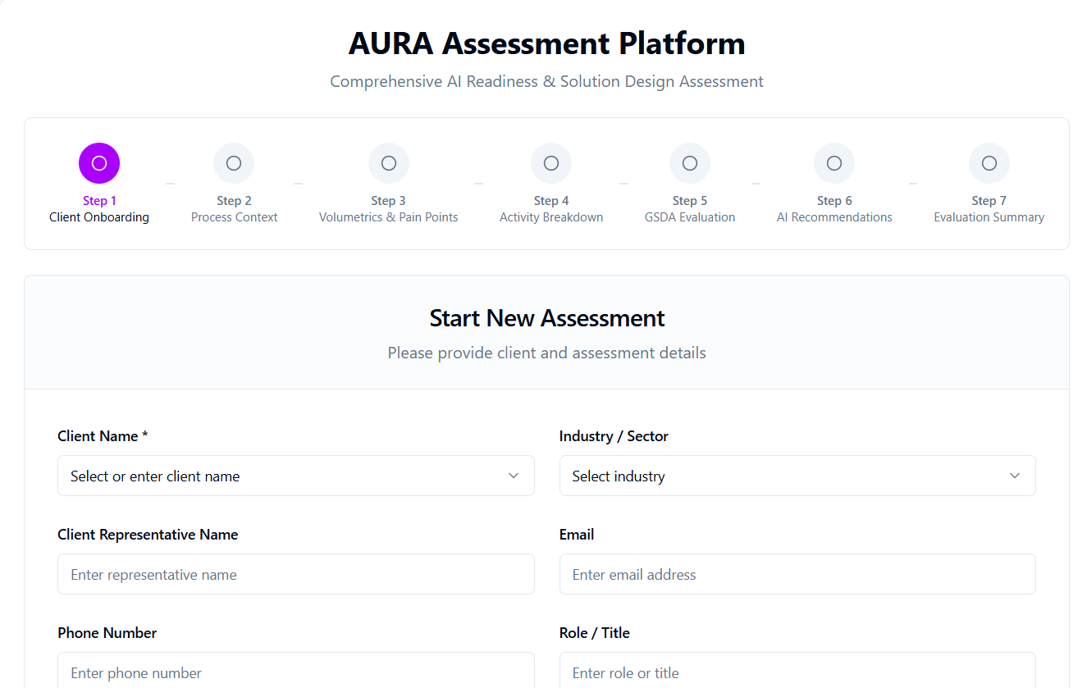
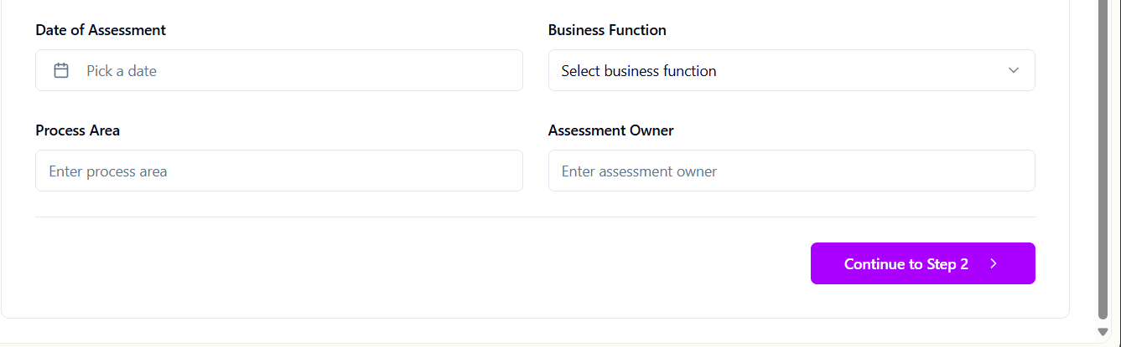

High Level Process Context:
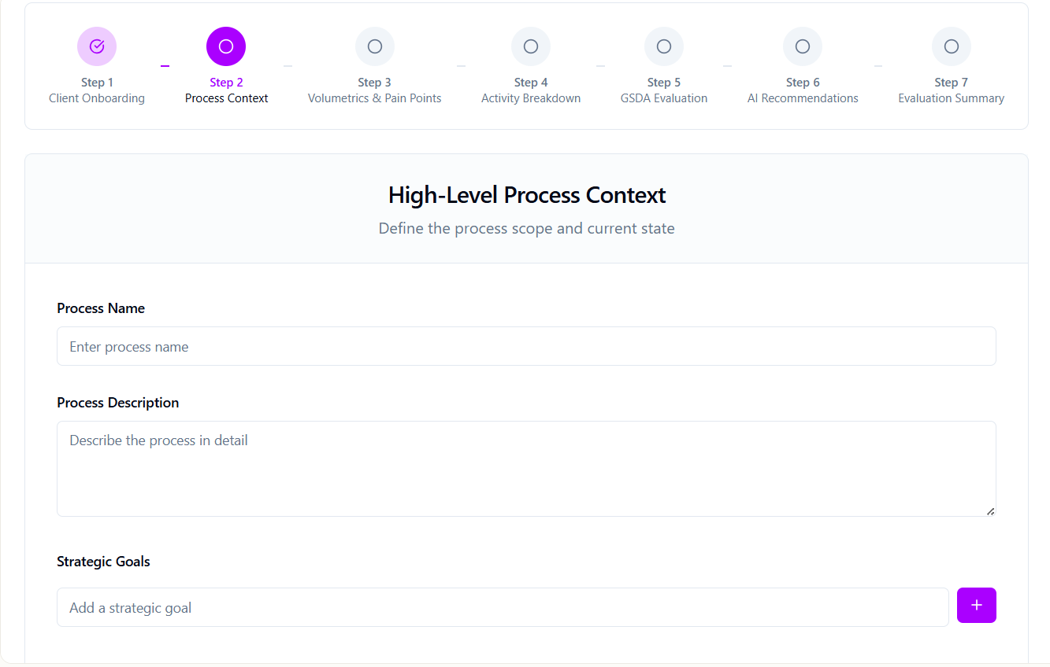
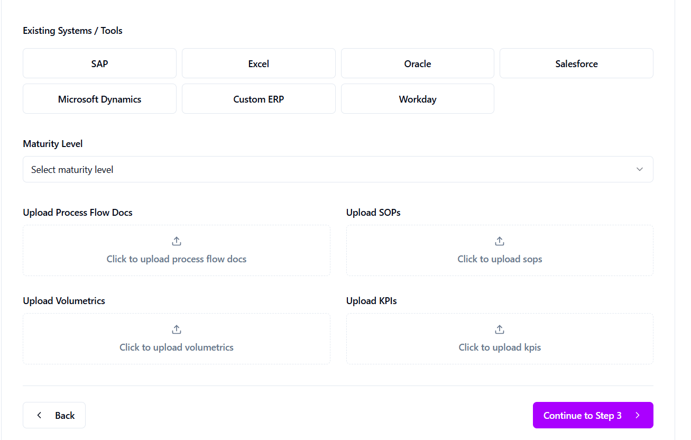
Process Volumetrics & Pain Points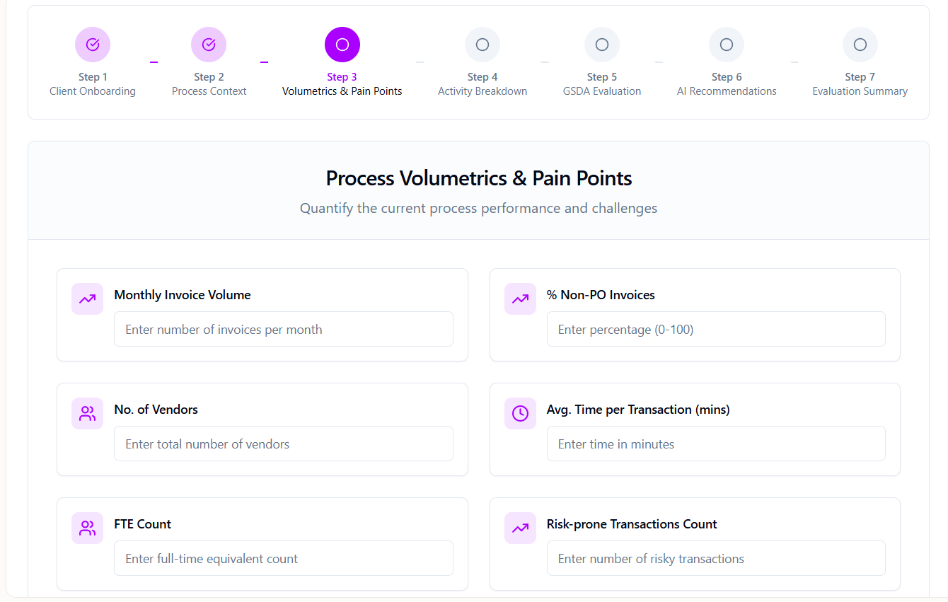
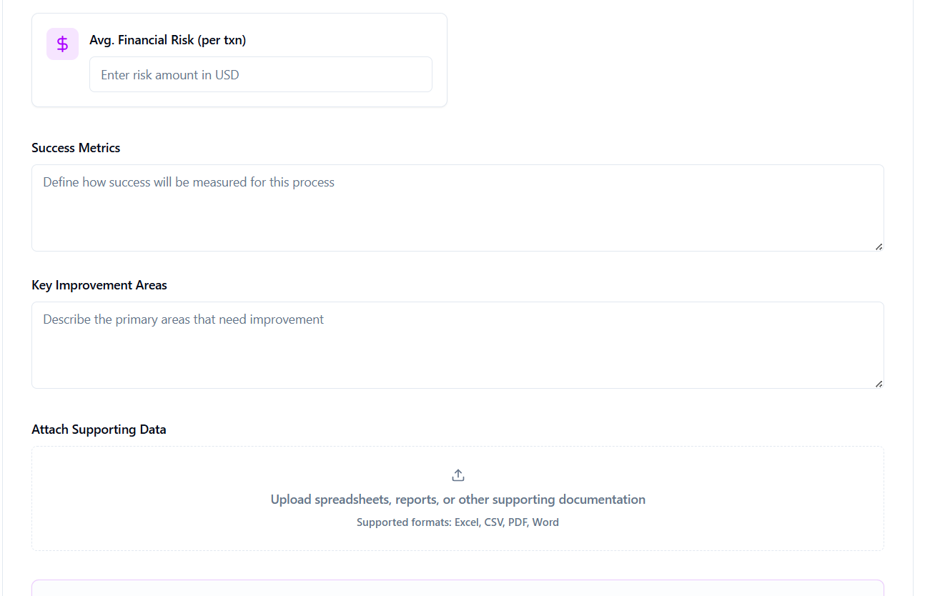
Activity Breakdown
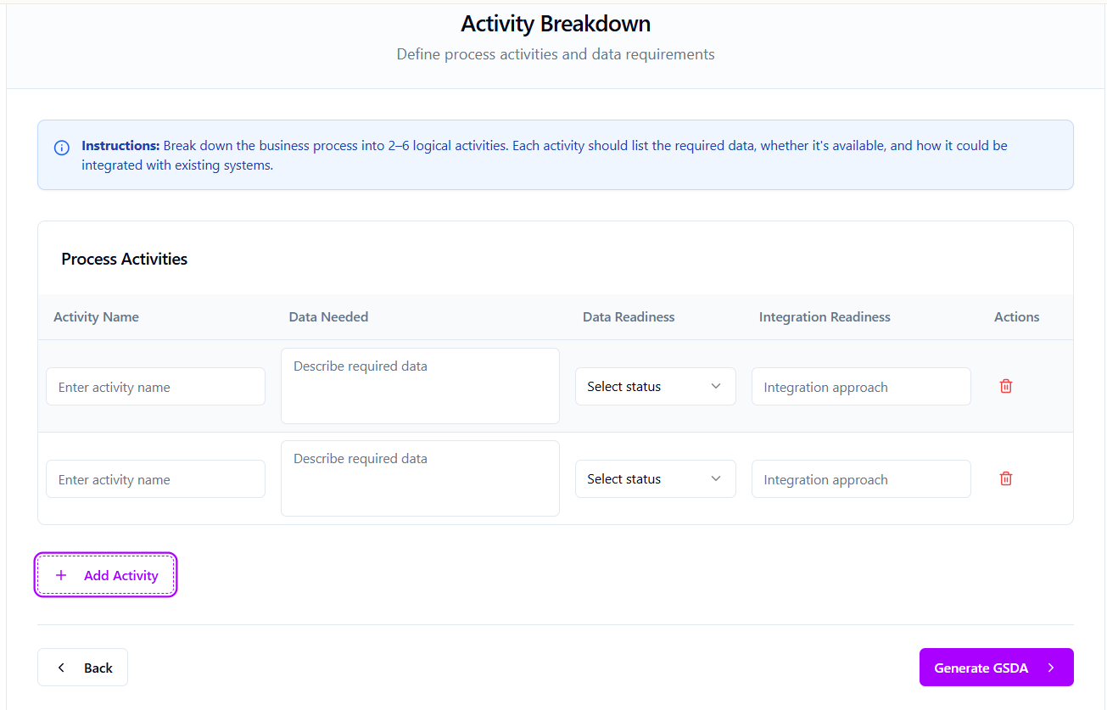

GSDA Evaluation:

AI Solution Recommendations:
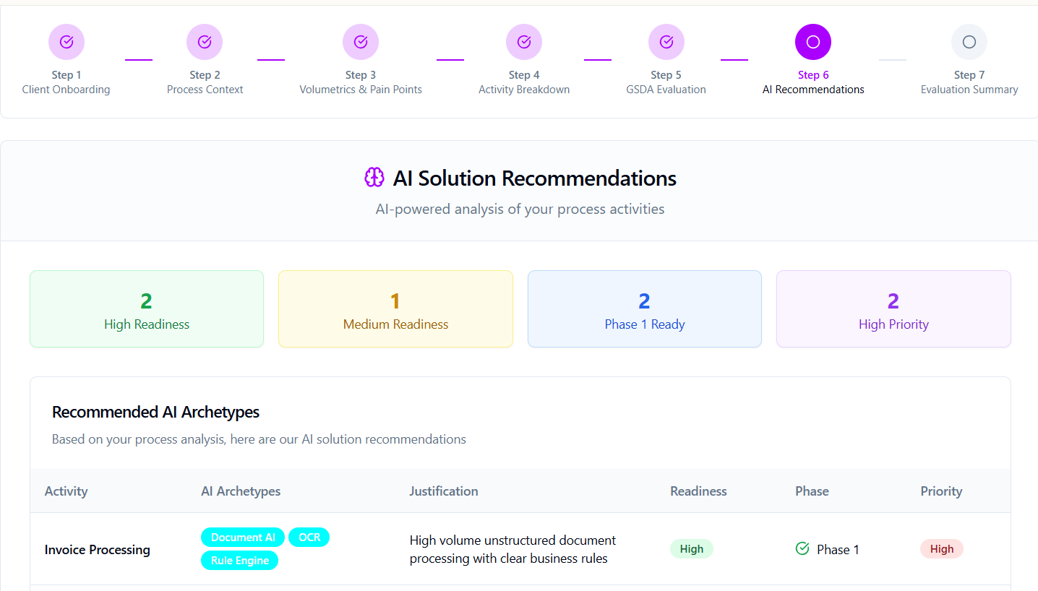
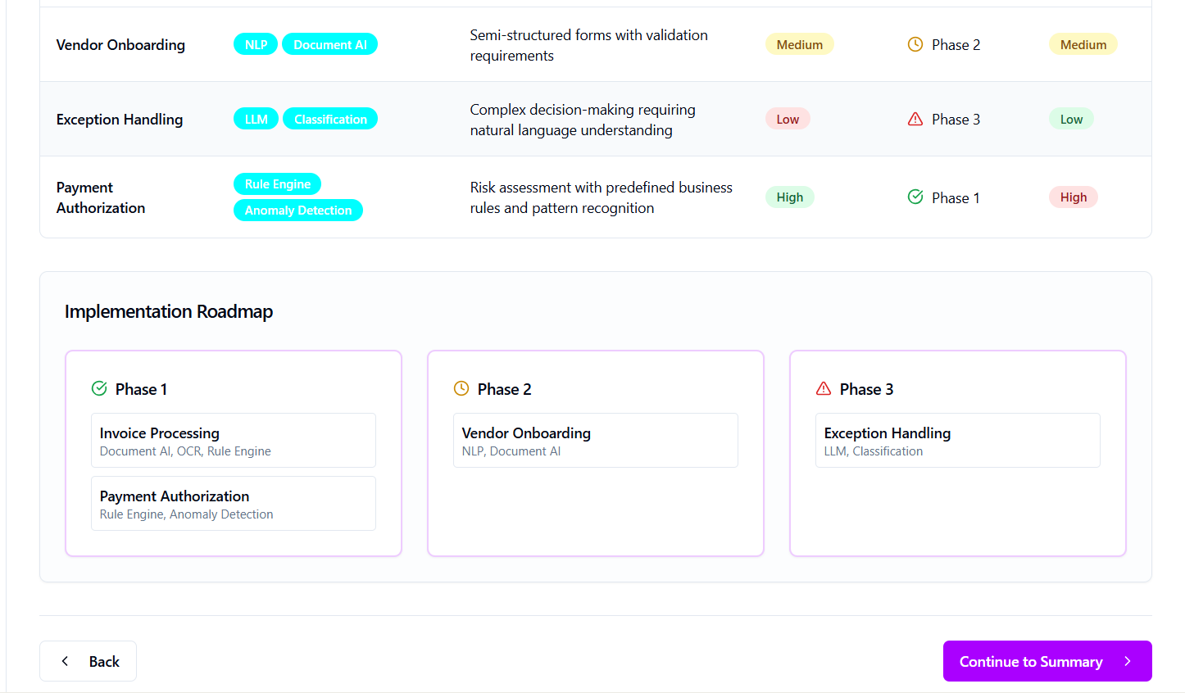

Evaluation Summary:
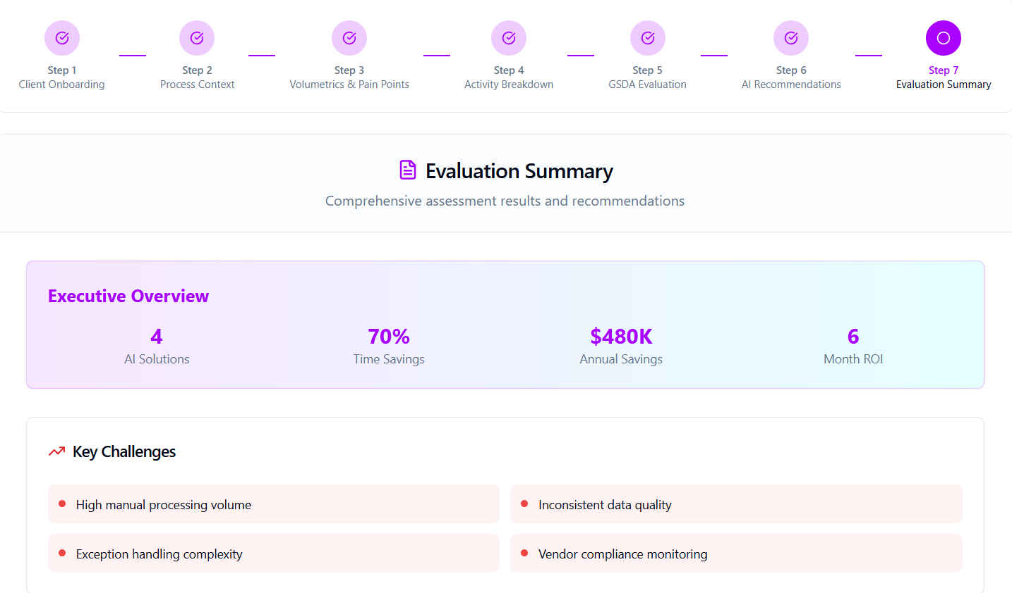
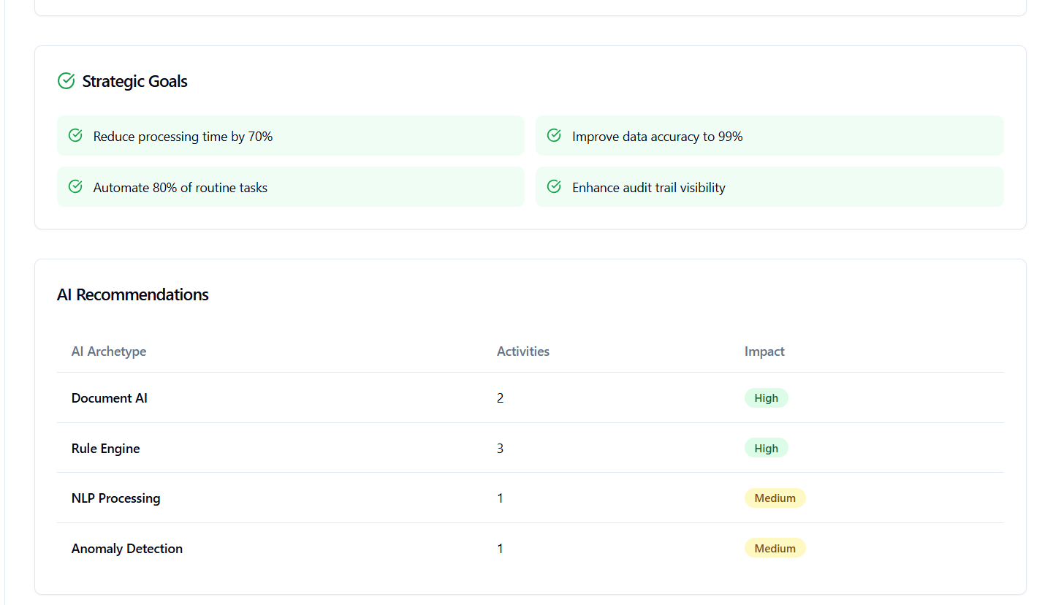
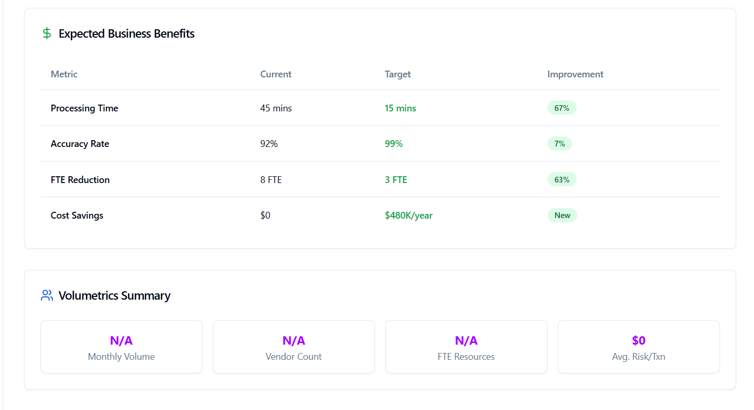
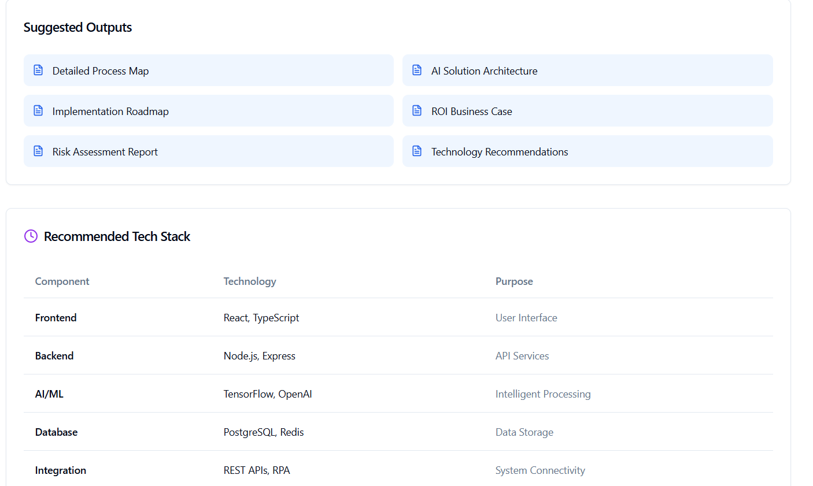
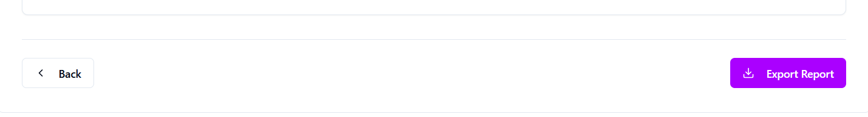

Query to Ask:
📥 Activity Breakdown Query Format (To Ask GPT):
Generate an Activity Breakdown table for the following process:

Client Name: [client_name]
Process Name: [process_area]
Process Description: [Short process context ]

Instructions:
Break the process down into logical activities (L3 level). For each activity, provide:
1. Activity Name – Descriptive task label
2. Data Needed – List of required input data fields for the task
3. Data Readiness – (Available / Partial / Missing)
4. Integration Readiness – Methods or feasibility to integrate with systems (e.g., SAP BAPI, Email Parsing, Manual, RPA, API)

Expected Output Format:
| Activity Name | Data Needed | Data Readiness | Integration Readiness |
|-------------------------|------------------------------------------------------------|----------------|----------------------------|

📥 GSDA Evaluation – Input Query Format (To Ask GPT):
Generate a GSDA (Goal, Signal, Decision, Action) Evaluation for the following activity:

Client Name: [client_name]
Process Area: [process_area]
Activity Name: [activity_name]
Data Needed: [data_needed from Screen 4]
Data Readiness: [data_readiness from Screen 4]
Integration Readiness: [integration_readiness from Screen 4]
Key Challenges: [key_challenges from Screen 2]
Goals and Objective: [strategic_goals from Screen 2]
Volumetrics:
- Monthly Invoice Volume: [invoice_volume from Screen 3]
- % Non-PO Invoices: [non_po_percent]
- FTE Count: [fte_count]
- Risk per Txn: [avg_risk_loss_per_txn]

Expected Output Structure:
-----------------------------
🔹 **Goal:**
- [What is the business goal for this activity?]

🔸 **Signal:**
- Input Trigger: [Event that starts the activity]
- Data Type: [Structured / Unstructured]
- System of Origin: [e.g., SAP, Outlook, Email Gateway]

🔸 **Decision:**
- Decision Logic: [Rule or condition to evaluate]
- Decision Criteria Source: [SOP + SAP master rules
- Complexity: Medium
- Manual Override: Yes
- Responsible Role: AP Team
- Exceptions Defined?: Yes (linked to Step 6)

🔸 Action:
- Task Flow: OCR > Field match > Validate > Route to approval
- System Used: Email, SAP, Rules Engine
- Estimated Duration: 4.5 mins
- Complexity: Medium
- AI Scope Suggestion: LLM + Rule Engine

📥 AI Archetypes Recommendation – GPT Query Format:

Suggest AI solution archetypes for each activity in the following business process:

Client Name: [client_name]
Process Area: [process_area]
Strategic Goals: [strategic_goals from Screen 2]
Key Challenges: [key_challenges from Screen 2]

Activities:
[List of activities from Screen 4 along with data type and integration readiness.]

Example Input Table:
| Activity Name | Data Type | Integration Readiness |
|-------------------------|-----------------|-------------------------------|
| Invoice Receipt | Unstructured | Email Parser + OCR |
| Invoice Validation | Structured | SAP Lookup |
| PO / Non-PO Matching | Structured | SAP BAPI |
| Approval Routing | Structured | Manual Rule Based |
| SAP Posting | Structured | SAP Plugin / RPA |

Expected Output Table:
| Activity Name | Suggested AI Archetypes | Justification | Implementation Readiness | Implementation Phase | Priority in Phase |
|-------------------------|-------------------------------|---------------------------------------------|---------------------------|------------------------|--------------------|

📥 Evaluation Summary – GPT Query Format:
Generate a complete AI Evaluation Summary based on the following AURA Assessment details:

Client Name: [client_name]
Process Area: [process_area]
Strategic Goals: [strategic_goals from Screen 2]
Key Challenges: [key_challenges from Screen 2]

AI Archetypes:
[List of activities from Screen 6 with recommended AI solutions]

Volumetrics:
- Monthly Invoice Volume: [invoice_volume from Screen 3]
- % Non-PO Invoices: [non_po_percent]
- No. of Vendors: [vendor_count]
- Risk-prone Transactions: [risky_txn_count]
- Avg. Financial Risk per Txn: [avg_risk_loss_per_txn]
- FTE Count: [fte_count]

Expected Output Format:

🔺 Key Challenges
🎯 Strategic Goals
🤖 Recommended AI Archetypes (tabular by activity)
💡 Expected Business Benefits
📊 Volumetrics Summary
✅ Suggested Outputs (post-automation outputs)
🛠 Recommended Tech Stack (for deployment)

